**Sprint** 3 **-** Agility **Design Document**

November 17**, 20**22

# Executive Summary

## ***Project Overview***

This product is a robot with the capabilities of traveling across the entire Agility course in room HH208. The intended audience is the professor and students of CS-104 01.

## ***Purpose and Scope of this Specification***

Programming of robot to travel the Agility course in room HH208. Intended audience are the professor and students of CS 104 01.

# Product/Service Description

## ***Product Context***

The product relates to other robots, in that its sole purpose is to travel a layout course in room HH208 and help CS 104 students further understand problem solving. It is independent and self contained. It interfaces only within its own system. It programming a simple block code language in comparison to other AI robots that are being created using python mainly.

## ***User Characteristics***

* N/A, we have no customers.

## ***Assumptions***

Robots block code is going to have to be very precise in order to avoid the obstacles - aim will be a key factor.

Robot will more accurately travel the path if it stops and delays before turning likely.

Robot is less likely to skid of track if traveling at a slower speed

Robots stabilization will have to be turned off at a certain point probably

## ***Constraints***

* Project must be done using the Sphero robot only
* Only language allowed is block code
* Lack of actual security for the software

## ***Dependencies***

* Agility layout is a traversing of a zig zag layout containing a ramp, and a set of pins to hit at the end.
* Sensor data that we must submit at the end has to resemble the entirety of the agility course.
* Project’s due date is November 29 midnight

| **Req#** | **Requirement** | **Comments** | **Priority** | **Date Rvwd** | **SME Reviewed / Approved** |
| --- | --- | --- | --- | --- | --- |
| AGI_01 | Must accurately circumnavigate the entire agility course | N/A | 1 | 11/27 |  |
| AGI_02 | Must travel straight paths for certain distances | N/A | 1 | 11/27 |  |
| AGI_03 | Must be able to stop and turn into the next straight line without going off target. | N/A | 1 | 11/27 |  |
| AGI_04 | Must have enough speed at a certain point in order to roll onto the ramp. | N/A | 1 | 11/27 |  |
| AGI_05 | Must stop after accurately traveling the entire Agility course. | N/A | 1 | 11/27 |  |
| AGI_06 | Robot must at least hit 7 of the 10 pins at the end of the agility course. | N/A | 1 | 11/27 |  |
| AGI_07 | Robot must be fully designed to complete all previously stated requirements by Nov 29 | N/A | 1 | 11/27 |  |
| AGI_08 | Robots should travel at changing speeds throughout. For the ramp a high speed, for the pins a moderate speed, and for the zig zags a lower speed. | N/A | 3 | 11/27 |  |

## ***Security***

### **Protection**

Lead Programmer’s Sphero account with the block code will have a complex password. Sphero will only be signed into lead programmers phone to minimize chance of access leaking. Password for lead programmers Sphero account will be changed weekly. Sphero will be recorded and looked over to ensure that its path traveled matches to sensor data, to ensure there are no errors in our data recording.

### **Authorization and Authentication**

Authorization for access to software must be obtained directly from the lead programmer. Any changes must first be checked with the lead programmer.

# Requirements Confirmation/Stakeholder sign-off

Include documentation of the approval or confirmation of the requirements here. For example:

| **Meeting Date** | **Attendees (name and role)** | **Comments** |
| --- | --- | --- |
| 11/27/22 | Azeez Olapade Lead Programmer / Tester | N/A |
| 11/27/22 | Biyi Abass Lead Data Manager / Recorder | N/A |
| 11/27/22 | Sekou Diabate Assistant Tester / Data Manager | N/A |

# System Design

## ***Algorithm***

* Program Start
* Robot will roll a 0 degree path at 40 speed for 2.5 seconds
* Robot will delay for 1 second
* Robot will reset aim.
* Robot will roll a 90 degree path at 40 speed for 2.8 seconds
* Robot will delay for 1 second
* Robot will reset aim.
* Robot will roll a 270 degree path at 40 speed for 3.05 seconds
* Robot will delay for 1 second
* Robot will reset aim.
* Robot will roll a 90 degree path at 170 speed for 2 seconds
* Robot will delay for 1 second
* Robot will reset aim.
* Robot will roll a 130 degree path at 80 speed for 5 seconds
* Program End

## ***System Flow***

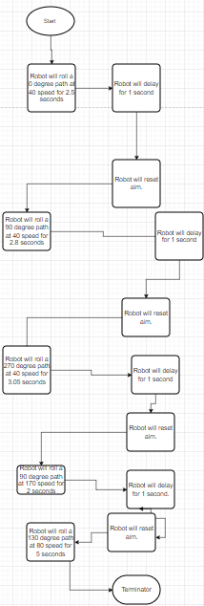

## ***Software***

The software language being used to develop this program is called block code which was originally translated from java functions. The platform this is deployed on is Sphero Edu, which is connected to our robots via bluetooth

## ***Hardware***

The hardware platform that was used is called Sphero Sprk+.

## ***Test Plan***

| **Reason for Test Case** | **Test Date** | **Expected Output** | **Observed Output** | **Staff Name** | **Pass/Fail** |
| --- | --- | --- | --- | --- | --- |
| To determine whether the robot will successfully travel the first zig zag rolling 0 degrees at a speed of 40 over 2.5 seconds. | 11/28 | Success | Success | Azeez | Pass |
| To determine whether the robot will successfully travel the second zig zag rolling 90 degrees at a speed of 40 over a 2.5 seconds. | 11/28 | Success | Fail | Azeez | Fail |
| To determine whether adding a reset aim function in between turns will increase overall accuracy | 11/28 | Success | Success | Azeez | Pass |
| To determine whether the robot will successfully travel the second zig zag rolling 90 degrees at a speed of 40 over a 3.0 seconds. | 11/28 | Success | Fail | Azeez | Fail |
| To determine whether the robot will successfully travel the second zig zag rolling 90 degrees at a speed of 40 over a 2.8 seconds. | 11/28 | Success | Success | Azeez/Biyi | Pass |
| To determine whether the robot will successfully travel the third zig zag rolling 270 degrees at a speed of 40 over a 3.0 seconds. | 11/28 | Success | Success | Azeez/Biyi | Pass |
| To determine whether the robot will successfully travel over the ramp rolling 90 degrees at a speed of 150 over a 2.0 seconds. | 11/28 | Success | Success | Azeez/Biyi | Fail |
| To determine if the robot will be in more optimal position to hit the pins if it travels the ramp rolling 93 degrees at a speed of 170 over 2.0 seconds | 11/29 | The robot will be in an overall more optimal position to hit pins. | The robot is now in an overall more optimal position to hit pins. | Azeez/Biyi | Pass |
| To determine if the robot will hit at least 5+ pins rolling 135 degrees at speed of 100 for 5 seconds | 11/29 | At least 5 pins successfully hit. | 6 pins hit. | Azeez/Biyi | Pass |
| To determine if the robot will hit at least 7+ pins rolling 130 degrees at a speed of 80 for 5 seconds | 11/29 | At least 7 pins successfully hit. | 8 pins hit. | Azeez/Biyi | Pass |

## ***Task List/Gantt Chart***

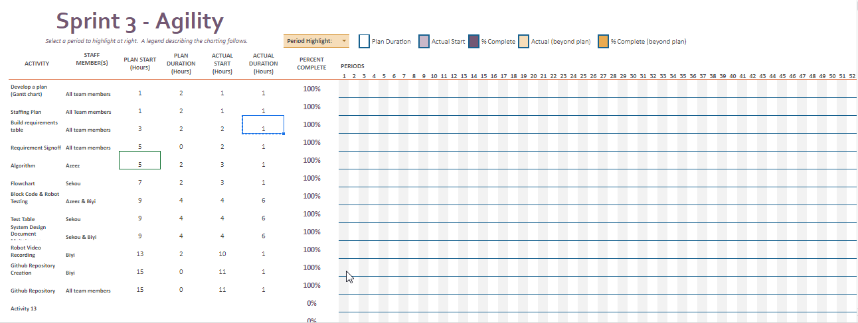

## ***Staffing Plan***

| Name | Role | Responsibility | Reports To |
| --- | --- | --- | --- |
| Azeez | Lead Programmer / Tester | To develop the algorithm that the block code will follow, and to make revisions to either accordingly. Also to test the robot in order to ensure that the code was done accurately. | No one. |
| Sekou | Lead Data Manager / Recorder | To convert the algorithm into a flow chart, and also to record test data. Data manager also maintains System Design Document, and as well as that records the finished project in the robot video. Creates Github Repository. | Azeez |
| Biyi | Assistant Tester/Data Manager | Doesn’t have a task to himself mainly, but assist other group members along in their jobs, giving insight, and also suggesting his own ideas and work to main project | Azeez |

